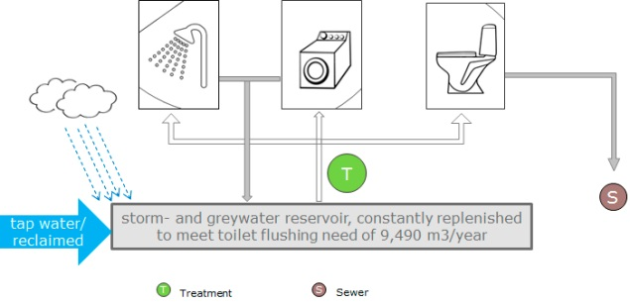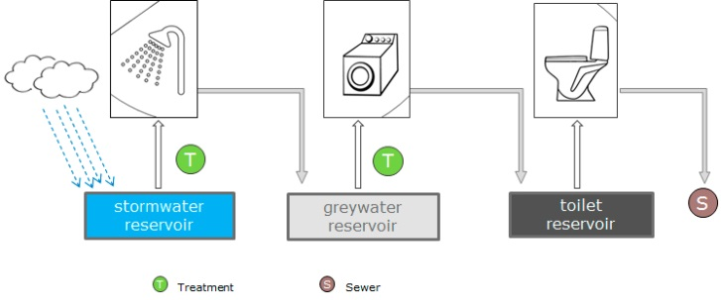

Figur 1: Illustration af Downgrading (tv) og Upgrading (th) principper for rensning af gråvand, hvor også regnvandsopsamling indgår. T står for treatment og S for sewer. Efter Liu et al., 2014, Potential contributions to Beijing’s water supply from reuse of storm-and greywater. Journal of Southeast University, 30(2): 150–157.